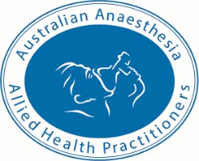

AAAHP Membership Application Form

First Name ………………………………………………….

Last Name……………………………………………………..

Email……………………………………………………………..

Mobile Number………………………………………………

Address…………………………………………………………………………………………………………………

……………………………………………………………………………………………………………………………

……………………………………………………………………..

Suburb…………………………………………………………………………………………….

State…………………………………………………………………………………………………

Date of birth……………………………………………………………………………………………………….

Nationality…………………………………………………………………………………………………………..

Gender………………………………………………………………………………………………………………

Passport Sized photo submitted Y/N………………………………………………………
Workplace………………………………………………………………………………………………………
Workplace address…………………………………………………………………………………………………………………………

……………………………………………………………………………………………………………………………………Membership Level
FULL/Student/Associate (Full and Student membership only available to Australian Residents)
Workplace state/territory (if Aust)…………………………………………………………………………………………………..
Copy of Anaesthesia qualification submitted Y/N………………………………………….
Professional qualification – Other……………………………………………………………………………………..

Institution qualified at…………………………………………………………………………………………………………………

All Student and Full membership Applications must be accompanied by a colour passport sized photo of the applicant plus a copy of the applicants Anaesthesia qualification or Student ID. All applicants will be notified by email of their membership status and will receive an Invoice with payment instructions.
DO NOT SEND PAYMENT WITH THIS APPLICATION
Full Membership $80
Student Membership $25
Associate Membership $55
Post to AAAHP registrar, PO BOX 656, Lavington, NSW, 2641 or email to registrar@aaahp.org.au

